KONGU ENGINEERING COLLEGE, PERUNDURAI – 638060

DEPARTMENT OF COMPUTER TECHNOLOGY – PG

18IST53– SOFTWARE TESTING

|  |
| --- |
| MINI PROJECT REPORT |

**E-HOSPITAL**

**TEAM MEMBERS**

A.B. ABINAYA - 18ISR001

R. DHARSHINI – 18ISR007

K. SAMYUGTHA-18ISR041

Submission Date:

|  |  |
| --- | --- |
| MINI PROJECT | **MARKS (5)** |
|  |

|  |  |  |
| --- | --- | --- |
| SI. No | CONTENT | PAGE NUMBER |
| 1. | ABSTRACT |  |
| 2. | PROPOSED METHODOLOGY |  |
| 3. | MODULES DESCRIPTION |  |
| 4. | SCREEN SHOTS |  |
| 5. | CONCLUSION |  |

**1. Abstract:**

* Care and Cure hospital website is designed to maintain patient records and favour the convenience of efficient hospital management.
* Hospital Management System is designed for multi-speciality hospitals, to cover a wide range of hospital administration and management processes.
* It is an integrated end-to-end hospital management System that provides relevant information across the hospital to support effective decision making for patient care, hospital administration and critical financial accounting, in a seamless flow.
* The hospital management can be benefited by using this application as it ensures clean and secure records, it is less time consuming, ensures efficient maintenance and results in less paper consumption.
* This application reduces the scope of error that accrue during manual registration.
* Doctor facilitates tracking of appointment fixed from the hospital records and can view their respective profile.
* Patients can select doctors based on their health care and facility convenience to fix their appointments through this application.
* Patients can also volunteer to donate their blood and organ by filing up the details provided in the form.
* Patients can fill the feedback form to express their experience about the services and diagnosis provided in the hospital.
* Patients can get to know about the room facility, ambulance facility and lab facilities that are provided in the hospital.
* With the advancement of information technologies and systems, patient records can be stored in databases, resulting in a positive impact on patient care.
* E-Hospital Systems is a customizable, comprehensive, and integrated Hospital Management System designed to enhance the overall health care experience in a health-care facility.

**2.Proposed Methodology:**

**3.Module Description:**

**A. Doctor Module**

**B. Patient Module**

**A. Doctor Module:**

i)Login Sub-Module:

a). In this module user (doctors) will have to give their correct user name , department and password to get login into their respective accounts.

b). In order to check the correctness of the login details we have used a servlet Page which fetch the details from the database.

c). After the correct login the users get into their respective accounts where they will see the corresponding 3 html pages.

ii)Home page:

The basic information about each department will be provided in this page.

iii)Profile Page:

The name, date of birth, age, gender, blood group, phone number,

e-mail, id, experience, speciality and address will be displayed in this page.

iv). Appointment:

The doctors can yet to know about the appointments that have been fixed.

v). Registration sub module:

The user(doctor) will have to register before they are entering into their corresponding accounts. Once they have register, they will be redirected to the login page. In order to register the user(doctor). We have used the servlet page to insert the detail into the database.

**B. Patient Module:**

i) Home:

In this page the user(patient) will get to know ab out the hospital.

ii)Room Facility:

In this page the user(patient) will get to know about the different types of rooms available in the hospital.

iii)Doctor Submodule:

In this page the user (patient) will have to select their respective speciality to fix their appointment.

iv) Appointment:

Here the user(patient) should fill the details that is given in the form to fix the appointment.

v)Ambulance Facility:

In the page the user(patient) will get to know about the ambulance facility available in the hospital.

vi)Laboratory:

In this page the user(patient) will get to know about the lab facility that are available in the hospital.

vii)Donation submodule:

A) Blood Donation:

* + - In this page the user(patient) will have to read and agree the condition that is given. Once after agreeing they will be redirected to the blood donation form page.
    - In this form page the user will have to fill the details asked in the form.
    - In order to check the given details satisfies the condition it will be accepted and the details will be registered in the database.

B) Organ Donation:

* + - In this page the user(patient) will have to read and agree the condition that is given. Once after agreeing they will be redirected to the organ donation form page.
    - In this form page the user will have to fill the details asked in the form.
    - In order to check the given details satisfies the condition it will be accepted and the details will be registered in the database.

viii)Feedback:

In this, the patient can share their experience about the service provided and the treatment given by our doctor.

ix)Contact Us:

In this page the user(patient) will get to know about the address, contact number and email address of the hospital.

**4.Screenshots:**

INDEX PAGE:

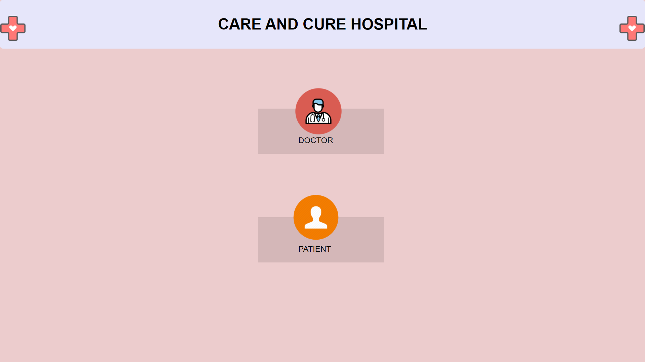

LOGIN PAGE:

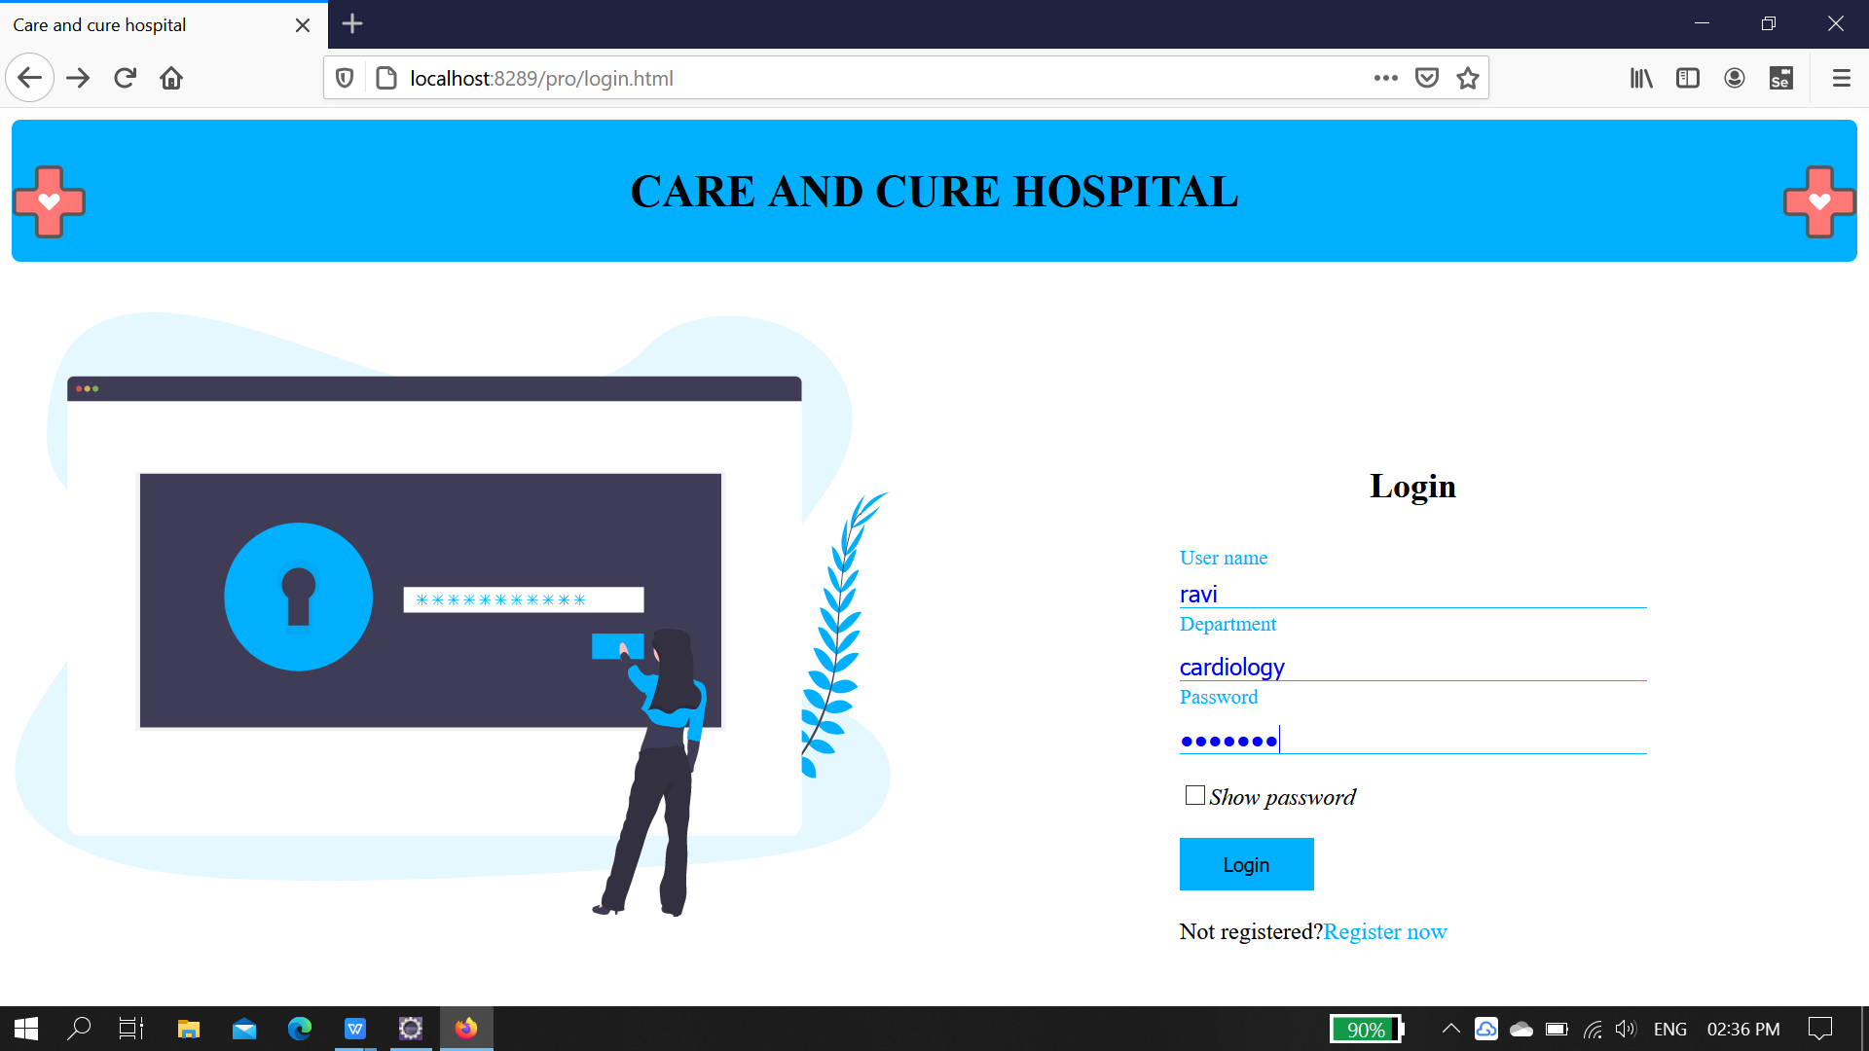

REGISTRATION PAGE:

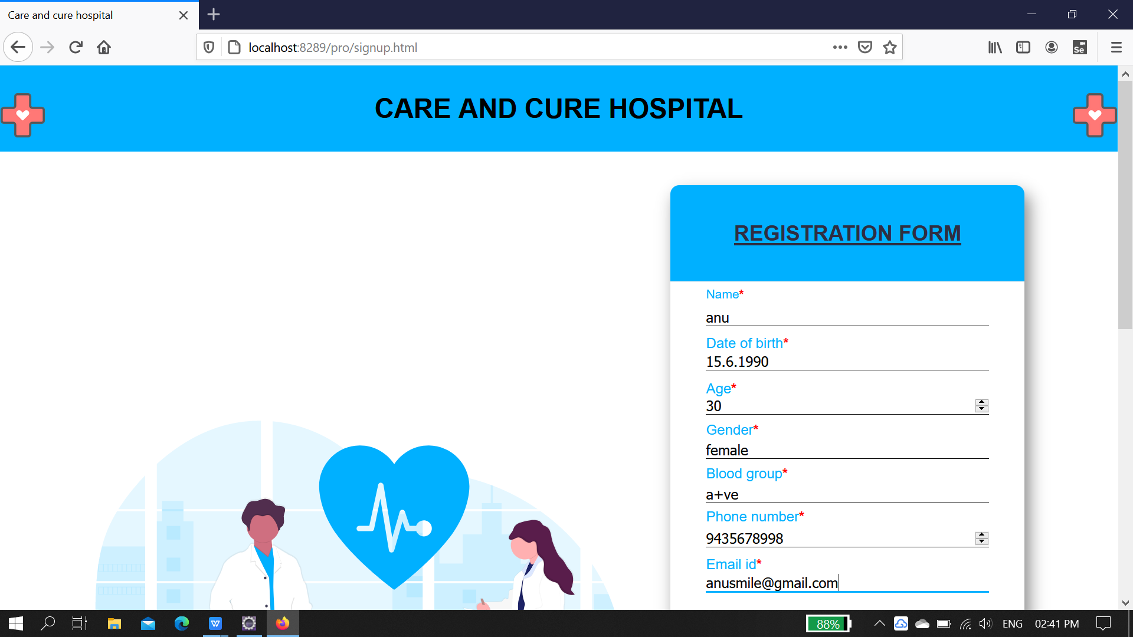

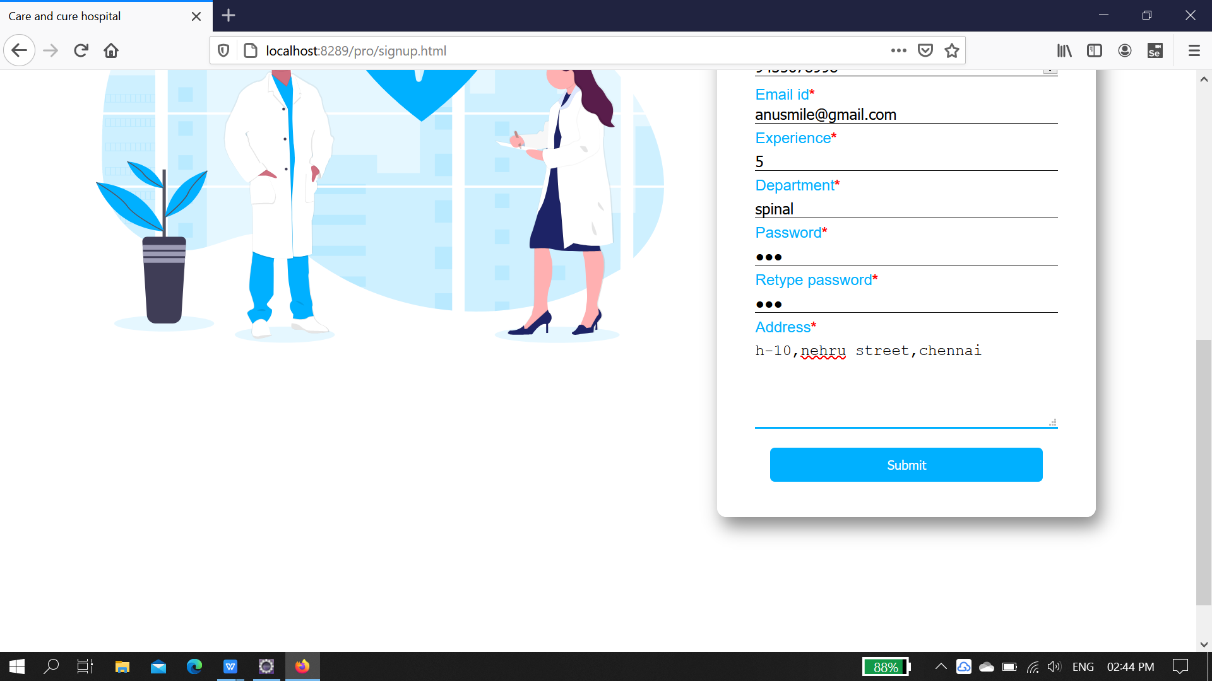

Home page of doctor module:

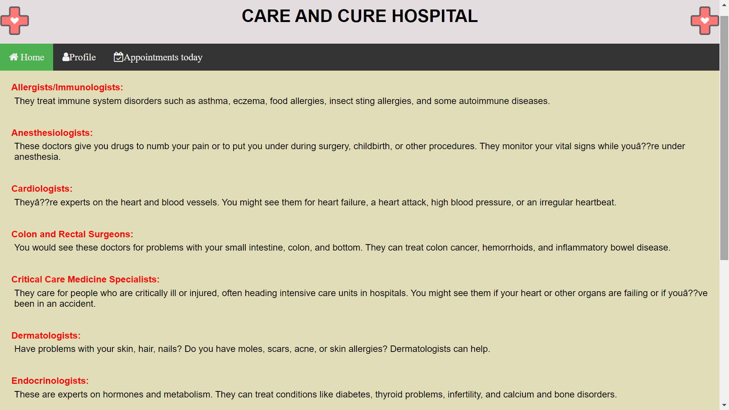

PROFILE PAGE:

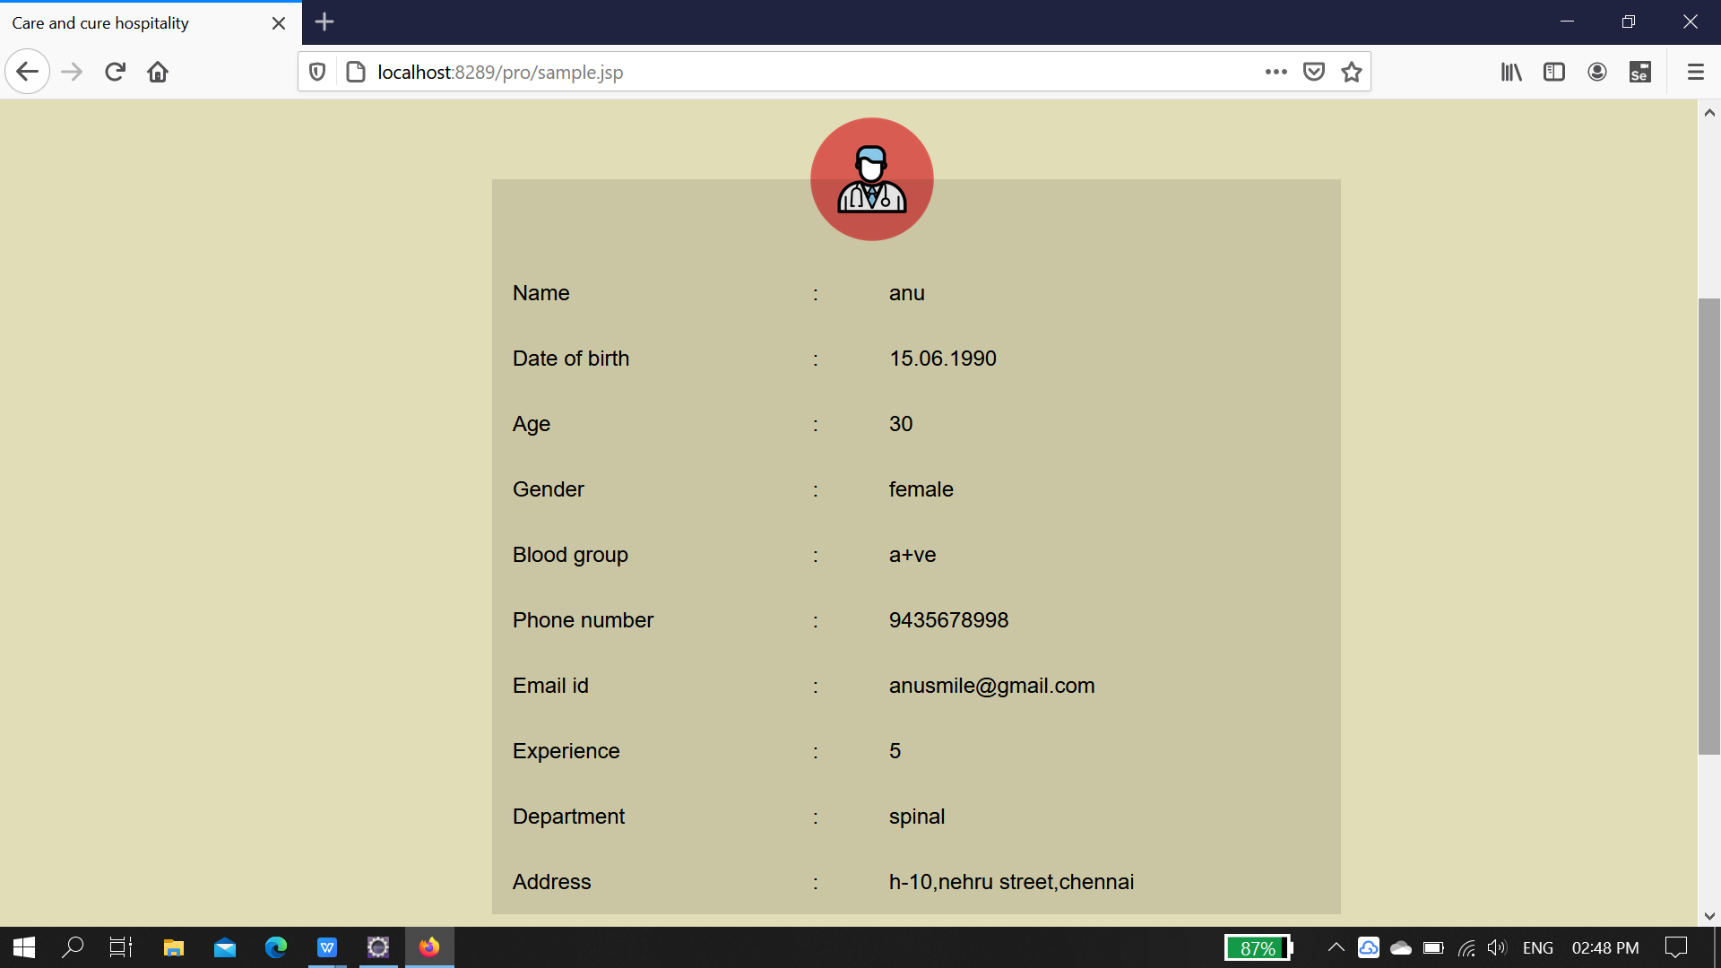

APPOINTMENT PAGE:

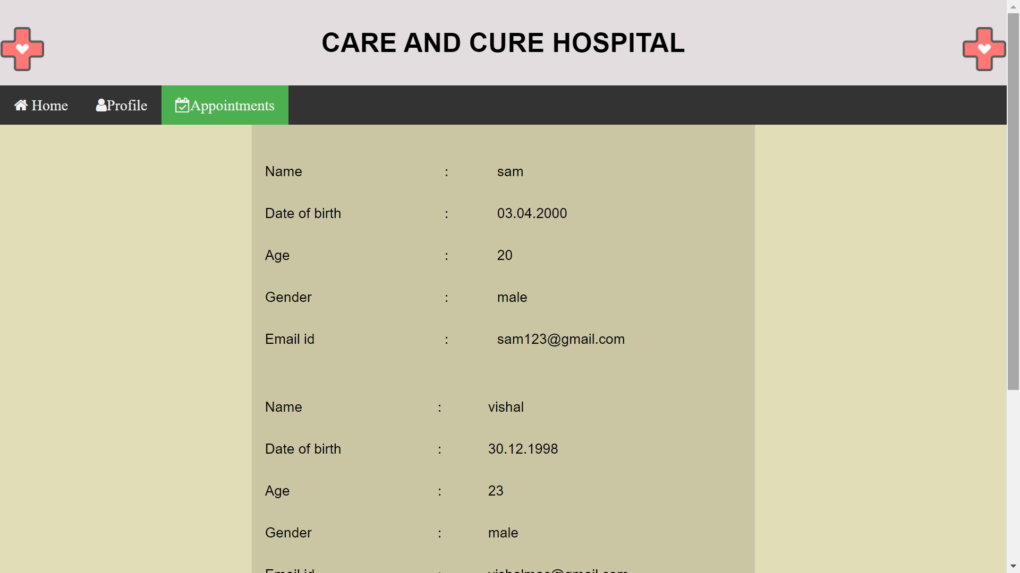

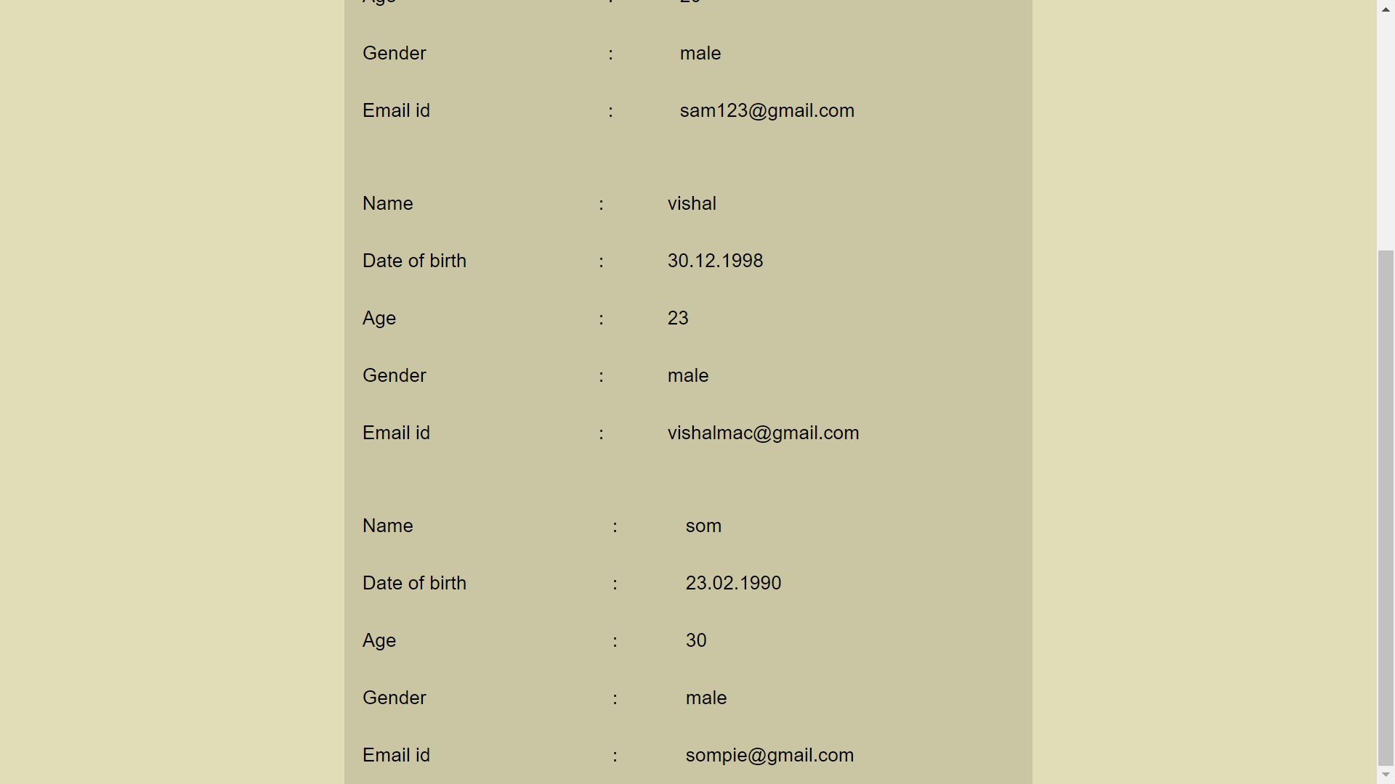

**PATIENT MODULE:**

HOME PAGE:

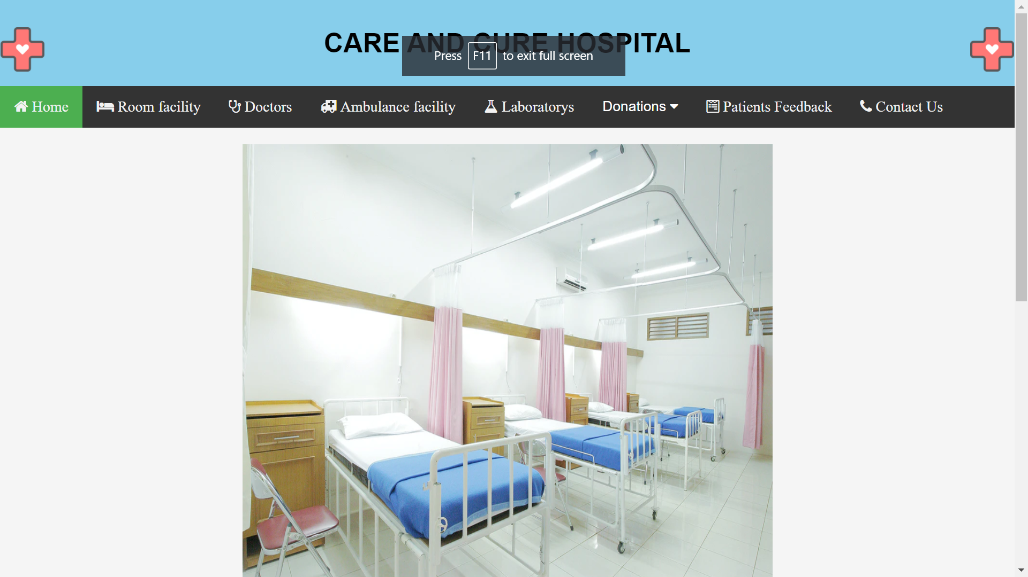

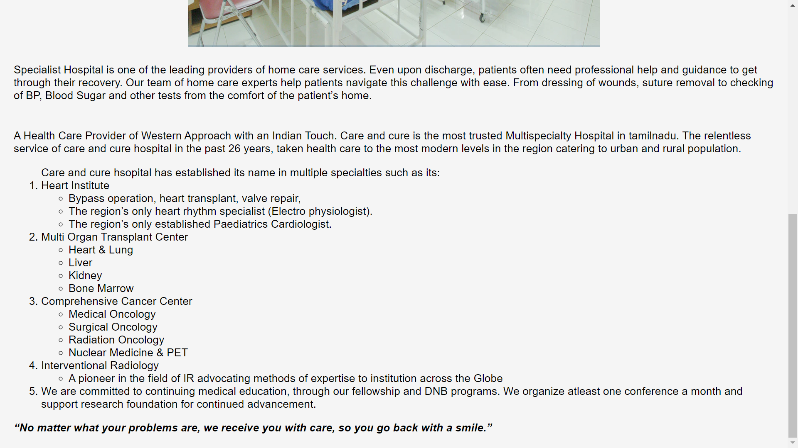

ROOM FACILITY:

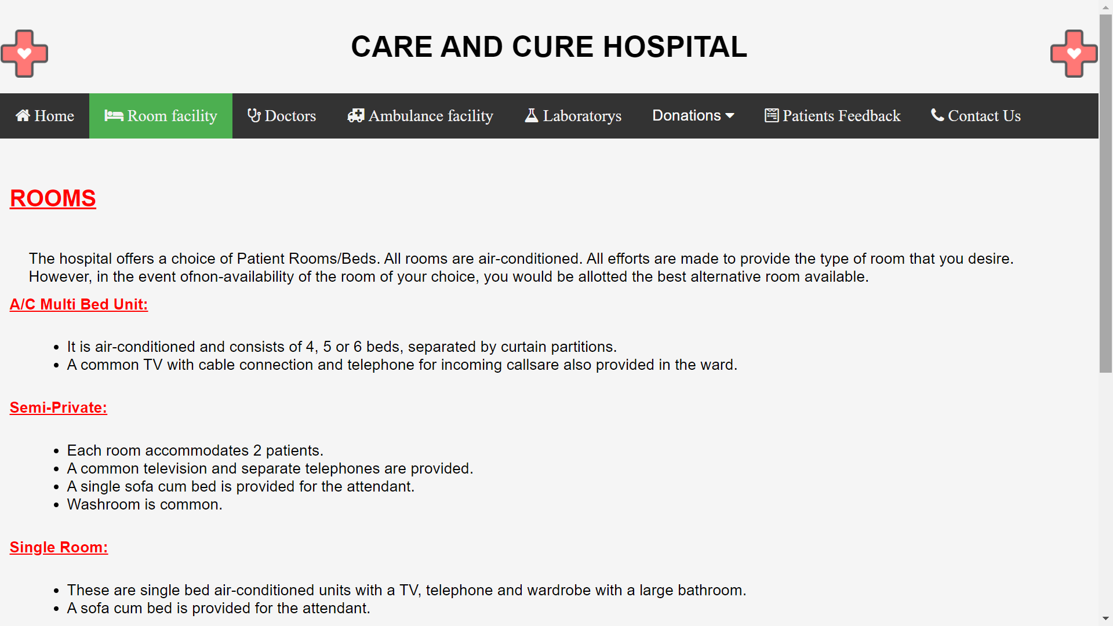

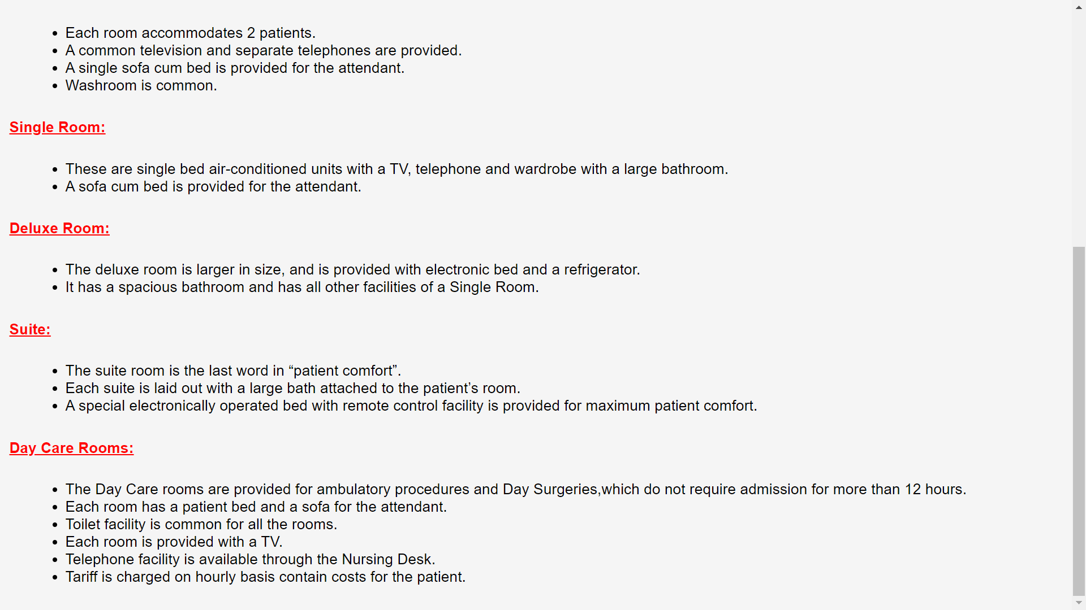

DOCTOR PAGE:

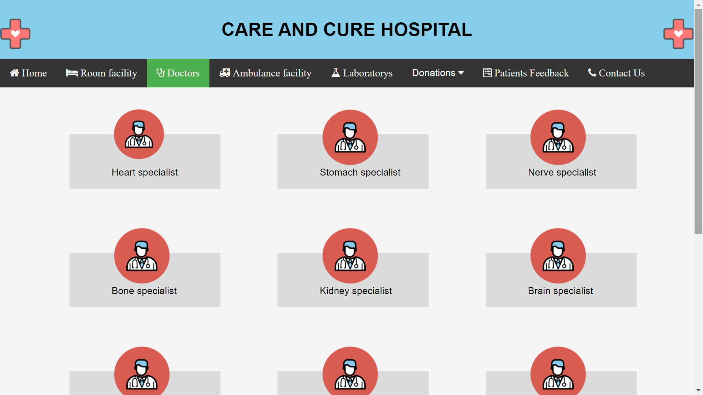

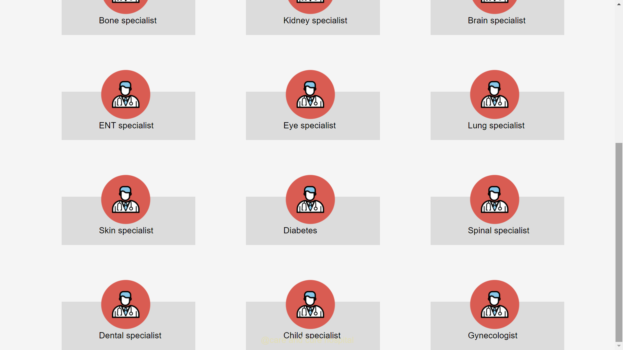

APPOINTMENT PAGE:

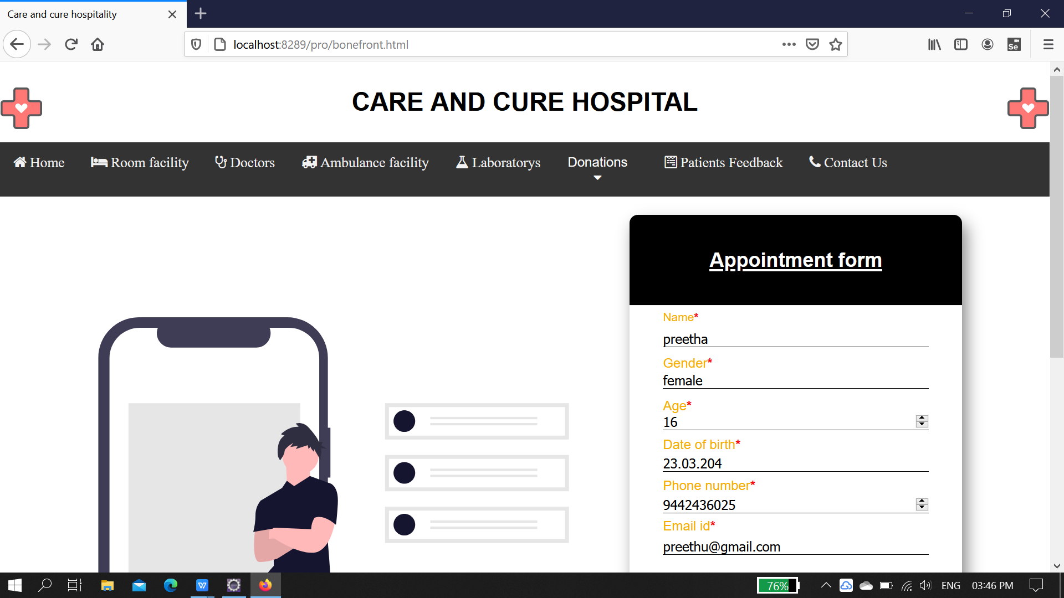

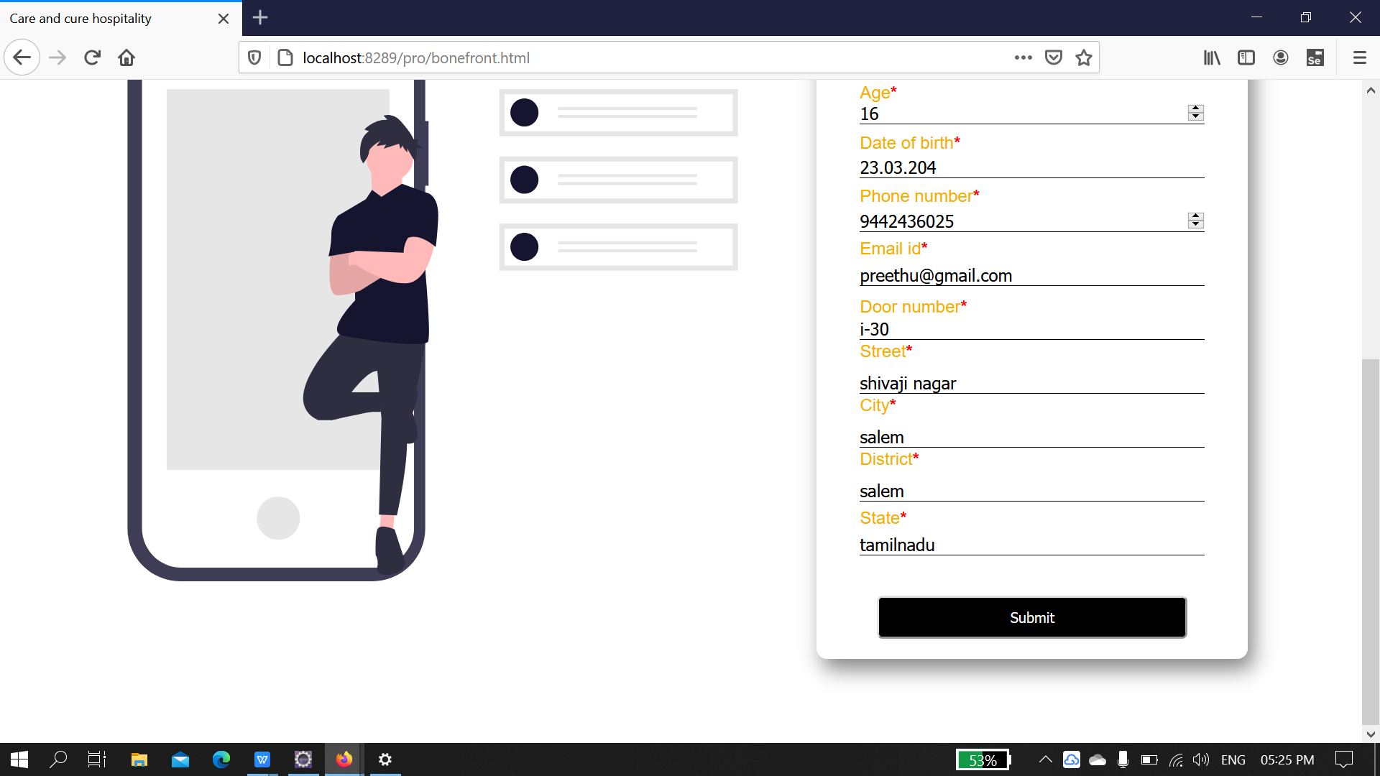

AMBULANCE FACILITY:

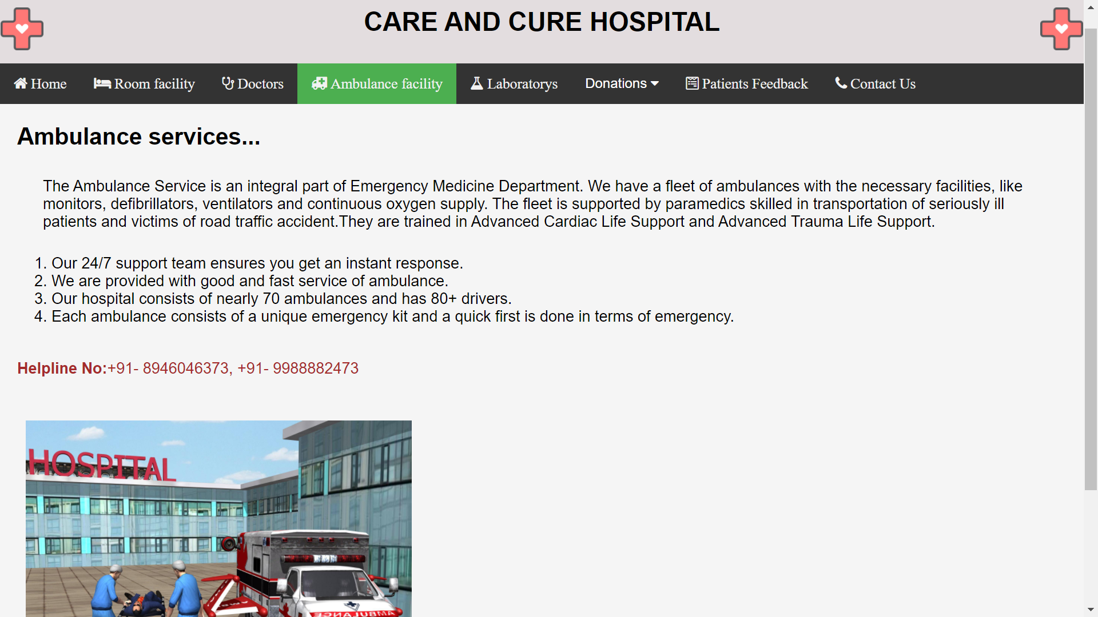

LABORARTY:

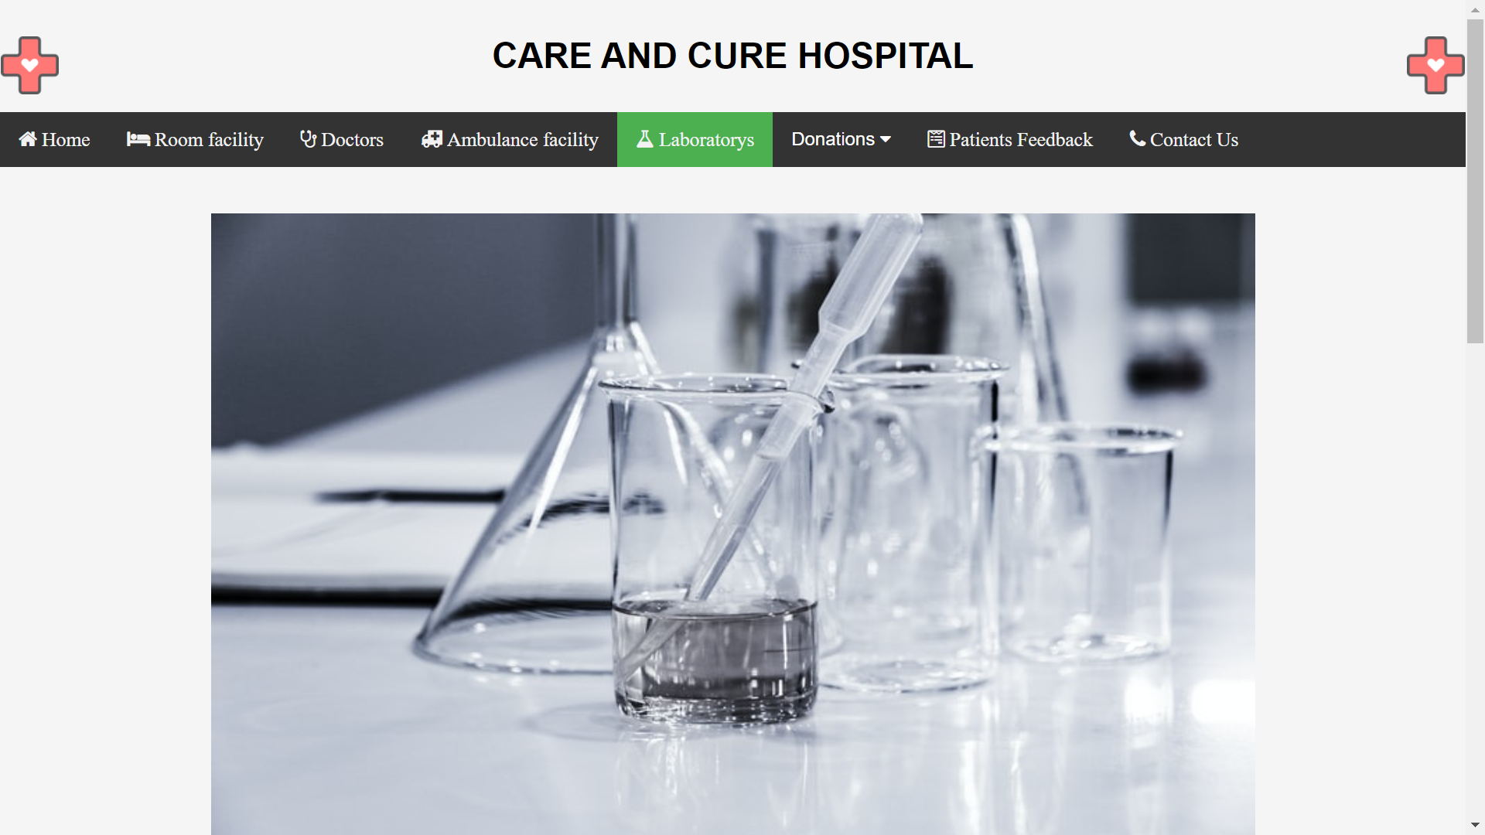

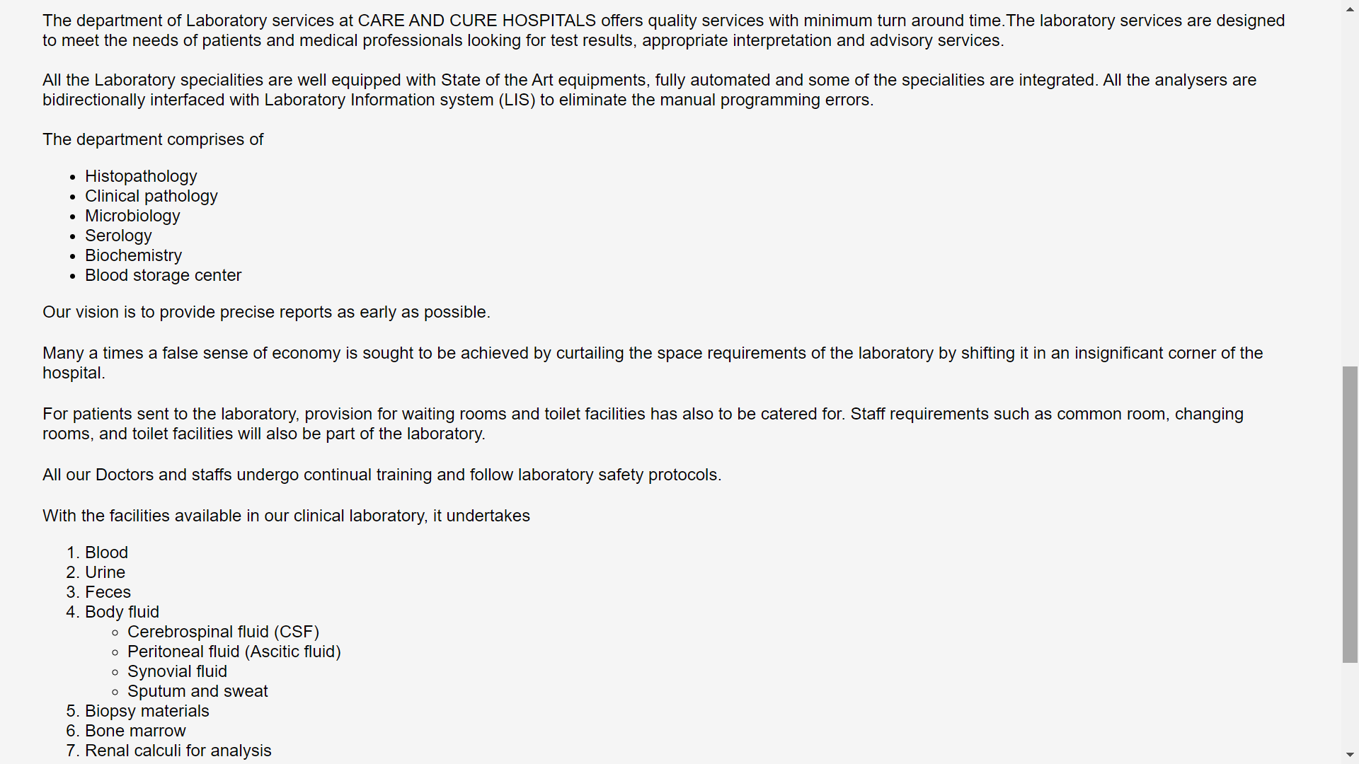

**DONATION SUB-MODULE:**

BLOOD DONATION PAGE:

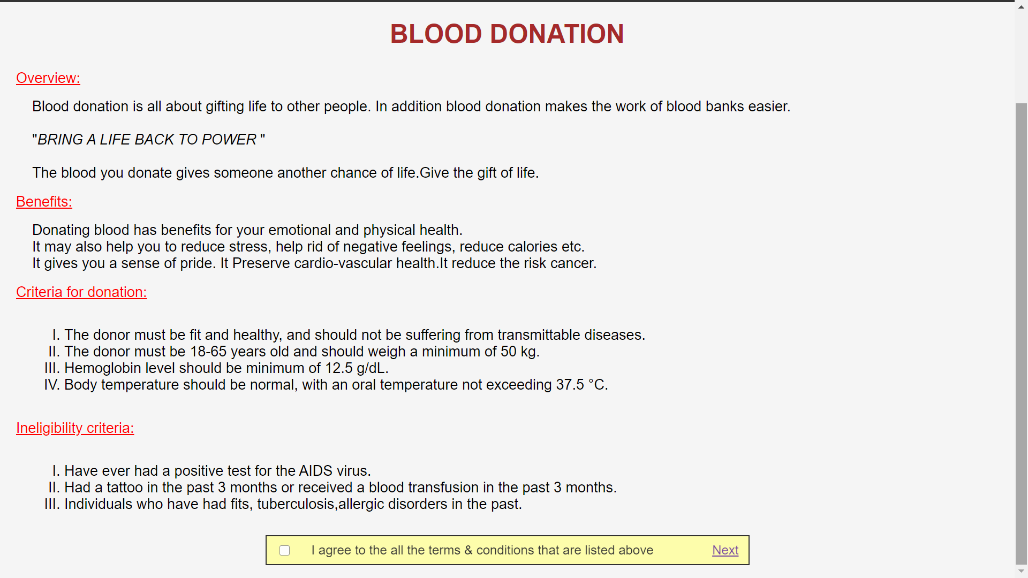

BLOOD DONATION FORM PAGE:

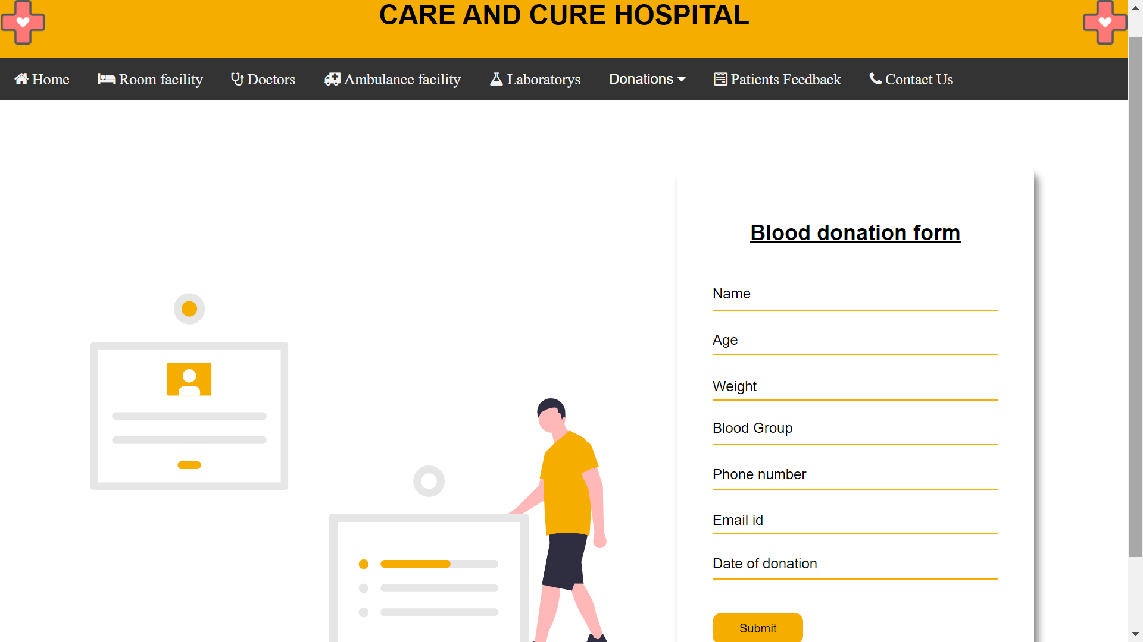

ORGAN DONATION:

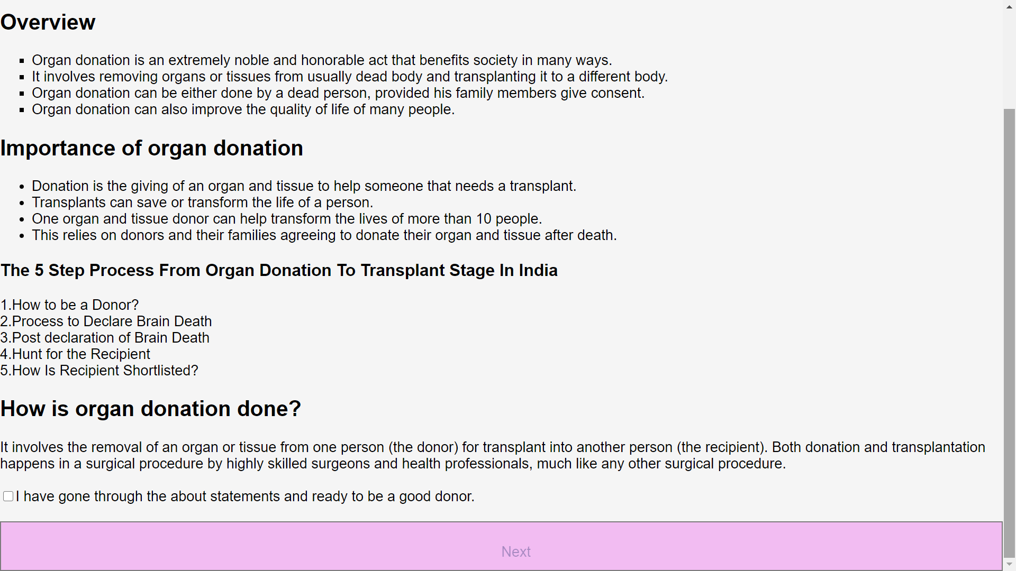

ORGAN DONATION FORM PAGE:

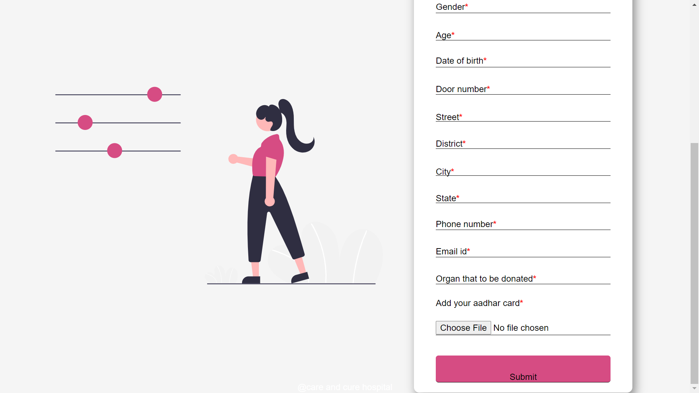

FEEDBACK PAGE:

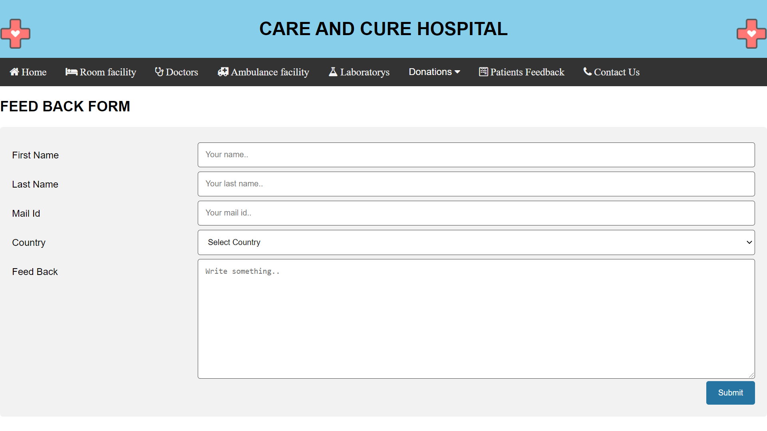

CONTACT US PAGE:

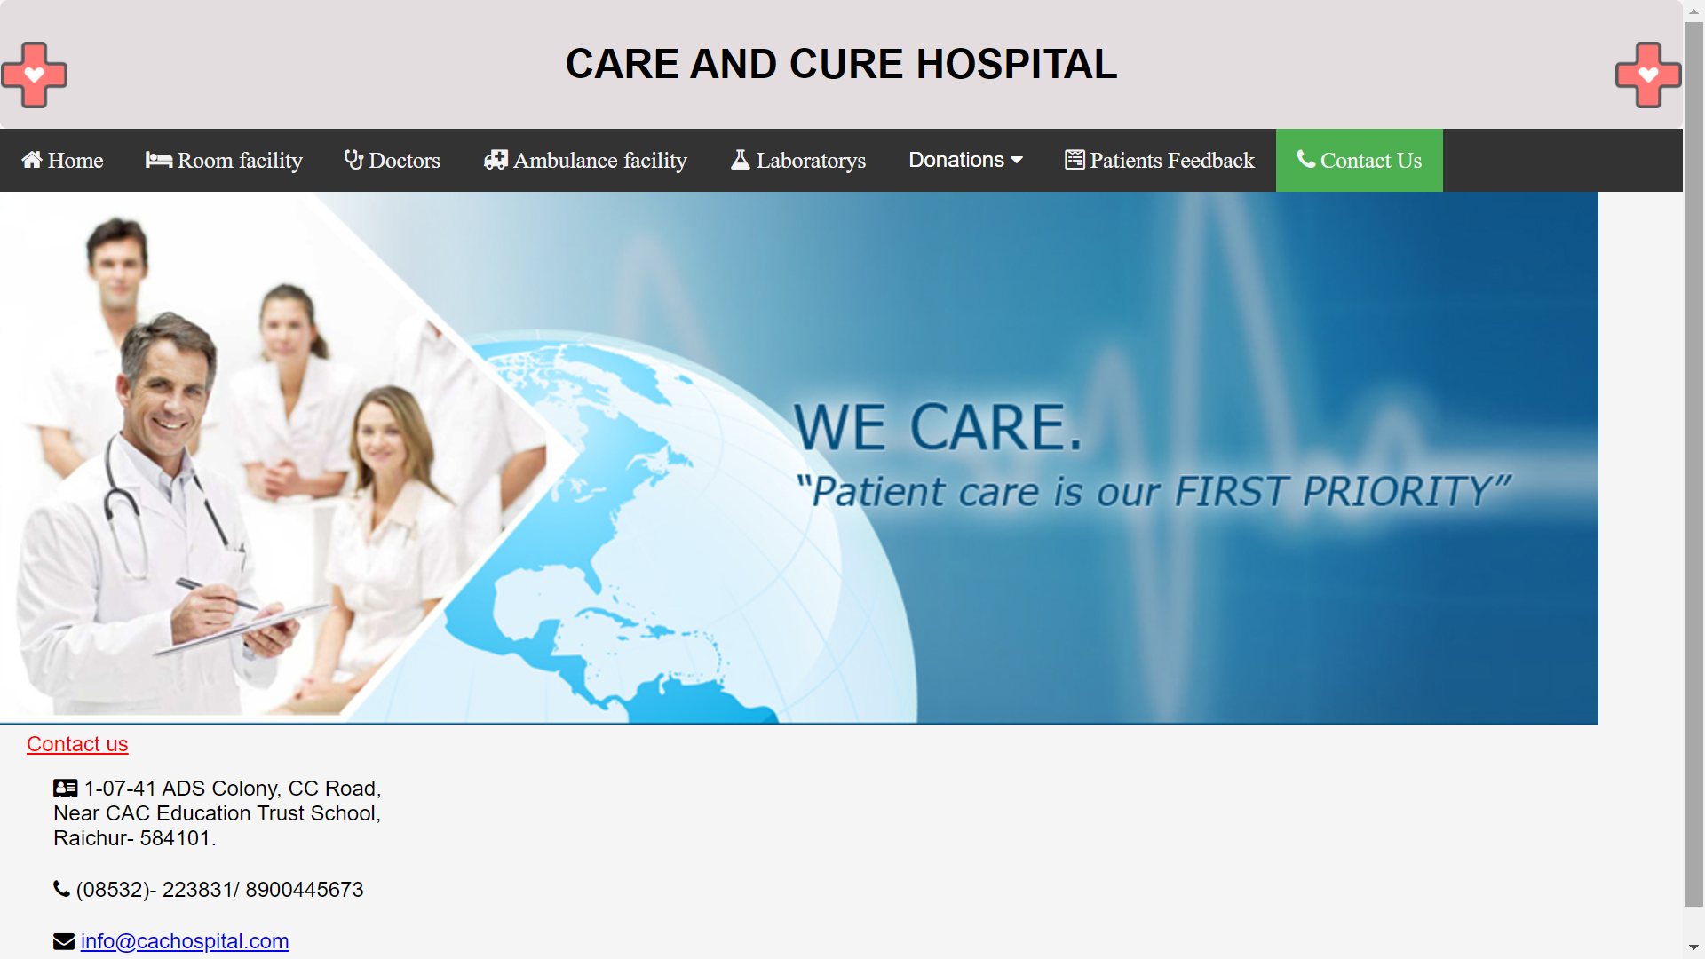

**5.Conclusion:**

The e-hospital is a web-based application which provides efficient way to patients, doctors and the hospital management to store the records fast and safe manner. Through this application patients can fix their appointments in respective health-care department and to get more knowledge about the hospital, whereas for the doctors they can view the appointments that have been fixed for them.

ss

